**Shree Moti Secondary School**

**Airawati-2, Baraula, Pyuthan,**

**Lumbini Provenience, Nepal**

A Project Report On

**Online Rural Municipality website**

**By:**

Ashim Khanal

Pashupati Raut

Nabin Shahi

Bikaram Acharaya

**ADIVISED BY**

**Er. Anil Kumar Thakur**

Computer instructor and Program coordinator

**Er. Sanjeev Kumar Raut**

Computer Instructor

**Pawan Bohara**

Sub- computer Instructor

**3 Month OJT Program of Computer Engineering After Class 11**

**Department of Computer Engineering**

**Shree Moti Secondary School**

**DECLARATION**

I here by declare that this is my own work. Materials of work found by other researchers are mentioned by reference. This project has been submitted for education as a part of the training.

……………………………

**Er. Anil Kumar Thakur**

Program Coordinator and Instructor

**Acknowledgement**

It is an honor for me to thank all those people who made this project possible. I want to thank my advisor Er. Anil Kumar Thakur, Er. Sanjeev Kumar Raut and Pawan Bohara. This would not be possible without their help and support. I also want to thank all my faculties and friends for their constant help throughout the whole time. I could not have done it without their help. Also. I want to thank to our parents and all the teachers of our school who has motivated us to complete the project.

It is also very important to give thanks to Google Drive which made the surveying and sharing very easy. At last but not the least, we would like to acknowledge with much appreciation the crucial role of the Eastern Region ICT Volunteers who co-operated, coordinated and gave of their time to complete this survey.

**Project Team Member:**

Asim Khanal

Pashupati Raut

Nabin Shahi

Bikaram Acharaya

**Abstract**

Our main focus is design a unique Rural municipality website that will improve data management in rural municipality experiences for both people and the Administration authorities. The whole system will run on the internet. The system is written in HTML CSS, javascript, and jQuery. Users will have the facility to log in from any place with internet connection. After that they will be able to various tasks that are designed for them. It can be turned into a paid system only for doctors where doctors can get additional cloud storage on payment. In the current system all the activities are done manually. It is very time consuming and costly. Our rural municipality website deals with various activities related to peoples.

**Table of Content**

Declaration 2

Acknowledgement 3

Abstract 4

**INTRODUCTION 5**

Existing System 6

Proposed System 7

Technical Feasibility 8

Economic Feasibility 9

Hardware Configuration 10

Software Configuration 11

Context Diagram 12

Input Data 14

End User Training 15

End User Education 16

Training Of Application Software 17

Post Implementation View 18

CONCLUSION 19

BIBLIOGRAPHY 20

**INTRODUCTION**

Rural Municipality Website (RMW) offers a modular approach to its system design. This modular design provides a clear understanding of the functionality RMW has to offer while providing you with the ability to purchase only modules that are necessary. The Core System provides overall system integration to all other Management Modules. Since these modules are so tightly integrated, the Core System modules are offered together as a package.

In addition to the core system, RMW offers a menu of optional Management Modules that increase the effectiveness and efficiency of many of the day to day operations required by rural municipality governments. Each Management Module manages a special area of your business. These modules are purchased separately; which makes RMW affordable, while also being expansive. It manage the staff and people.

**SYSTEM ANALYSIS**

EXISTING SYSTEM:

System analysis is detailed study of the various operation performed by a system and their relationships within and outside of the system. Here the key question is –what all problems exist in the present system ? what must be done to solve the problem ? Analysis beings when a user or manager begins a study of the program using existing system.

During analysis, data collected on the various files, decision points and transactions handled by the present system. The commonly used tools in the system are flow diagram , interviews, etc. training system. A good analysis model should provide not only the mechanisms of problem understanding but also the frame work of the solution. Thus, it should be studied thoroughly by collecting data about the system. Then the proposed system should be analyzed thoroughly in accordance with the needs.

**System analysis can be categorized into four parts.**

* System planning and initial investigation
* Information gathering
* Applying analysis tools for structured analysis
* Cost/benefit analysis

In the current system we need to keep a number of record s related to the people and want to enter the details of the people and the work manually . in this system only, the staff or the rural authority views the Work of the people and they want to enter the details of the people. This is time consuming and has much cost

**PROPOSSED SYSTEM :**

In our proposed system we have the provision for adding the details of the students by themselves. So, the overhead of the rural authorities and the staffs in become less. Another advantage of the system ids that it is very easy to edit the details of the people and delete a people when it found unnecessary. the marks of the people are added in the database and so people can also view the marks whenever they went.

**Our proposed system has several advantages**

* User friendly interface
* Fast access to database
* Less error
* More Storage Capacity
* Search facility
* Look and feel environment
* Quick transaction

All the manual difficulties in managing the people details in a rural municipality and municipality have been reified by implementing computerization.

**FEASIBILITY ANALYSIS**

Whatever we think need not be feasible. It is wise to think about the feasibility of any problem we undertake. Feasibility in the study of impact, which happens in the organization by the development of a system. The impact can be either positive or negative. When the positives or negative. When the positives nominate the negatives then the system is considered feasible. Here the feasibility study can performed in two ways such as technical feasibility and economical feasibility.

**TECHNICAL FEASIBILITY**

We can strongly say’s that it is technically feasible, since there will no be much difficulty in getting required resources for the development and maintaining

The system as well. All the resources needed for the development of the software as well as the maintenance of the same is available in the organization here we are utilizing the resources which are available already.

**ECONOMIC FEASIBILITY:**

Development of this application is highly economically feasible. The organization needed not spend much money for the development of the system already available. The only thing to be done in making an environment for the development with an effective supervision. I f we are doing so, we can attain the maximum usability of the corresponding resources. Even after the development , the organization will not be in condition to invest more in the organization. Therefore, the system is economically feasible.

**CONFIGURATION**

**HARDWARE CONFIGURATION :**

* Ram: 4GB
* Hard disk:1 TB
* SSD: 256GB
* Key board :
* Moniter: LCD
* Processer :AMD Rayzen 5
* Internet connection

**SOFTWARE CONFIGURATION :**

* Operating System (Linux, Windows, Mac)
* Database Server : MY SQL, PHP
* Language : HTML, CSS, JAVASCRIPT.
* Compatible Browser : Microsoft Edge

**Data Flow Diagram**

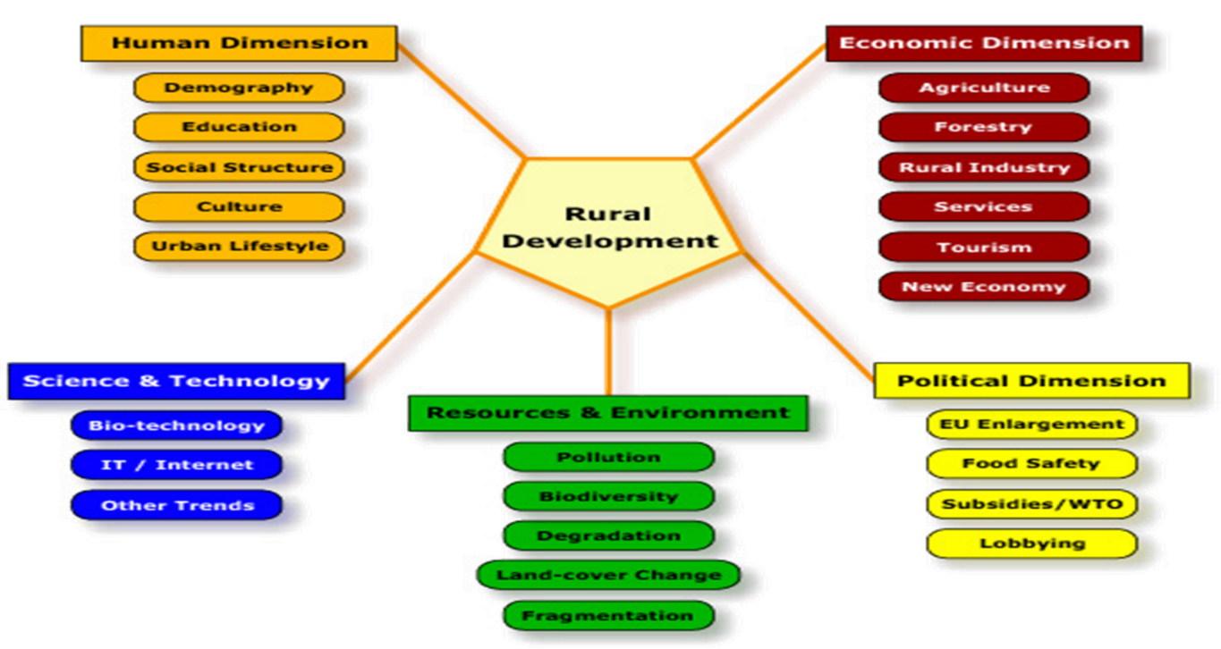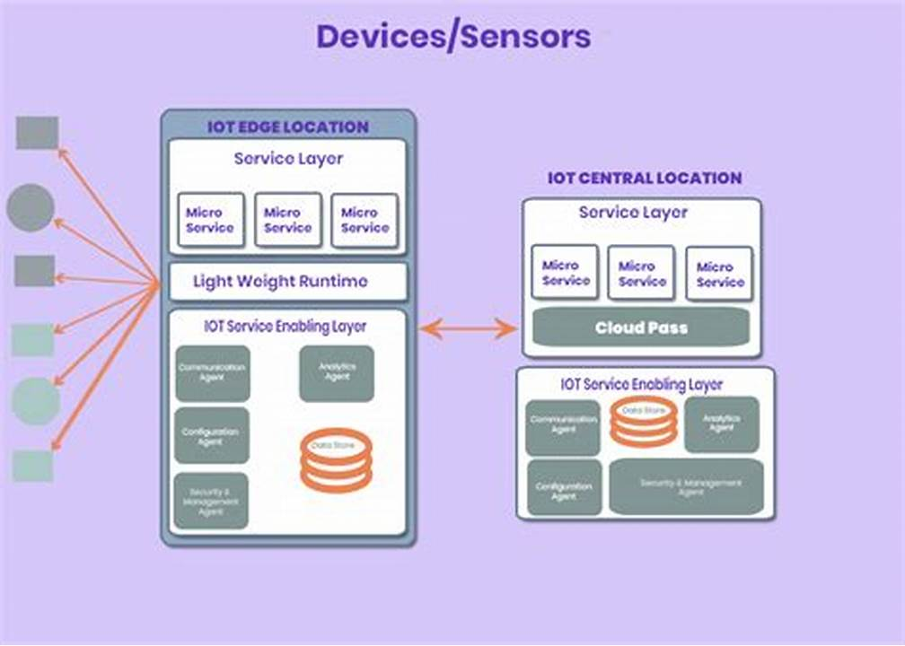Context Diagram

**Website interface**

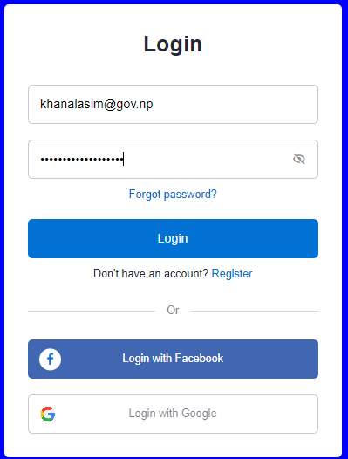 Login

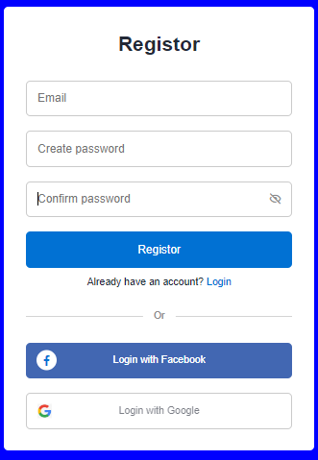

**Login source code**

**HTML:**

<section class="container forms">

<div class="form login">

<div class="form-content">

<header>Login</header>

<form action= "login.php" onsubmit = "return validation()" method = "POST" class="login" required>

<div class="field input-field">

<input type="email" name="email" placeholder="email" class="input">

</div>

<div class="field input-field">

<input type="password" name="pass" placeholder="Password" class="password" required>

<i class='bx bx-hide eye-icon'></i>

</div>

<div class="form-link">

<a href="#" class="forgot-pass">Forgot password?</a>

</div>

<div class="field button-field">

<input type="submit" value="Login">

</div>

</form>

<div class="form-link">

<span>Don't have an account? <a href="#" class="link signup-link">Register</a></span>

</div>

</div>

<div class="line"></div>

<div class="media-options">

<a href="#" class="field facebook">

<i class='bx bxl-facebook facebook-icon'></i>

<span>Login with Facebook</span>

</a>

</div>

<div class="media-options">

<a href="#" class="field google">

<img src="image/google.png" alt="" class="google-img">

<span>Login with Google</span>

</a>

</div>

</div>

<!-- Signup Form -->

<div class="form signup">

<div class="form-content">

<header>Registor</header>

<form action="insert.php" method="POST">

<div class="field input-field">

<input type="email" name="email" placeholder="Email" class="input">

</div>

<div class="field input-field">

<input type="password" name="password" placeholder="Create password" class="password">

</div>

<div class="field input-field">

<input type="password" placeholder="Confirm password" class="password">

<i class='bx bx-hide eye-icon'></i>

</div>

<div class="field button-field">

<input type="submit" name="submit" value="Register">

</div>

</form>

<div class="form-link">

<span>Already have an account? <a href="#" class="link login-link">Login</a></span>

</div>

</div>

<div class="line"></div>

<div class="media-options">

<a href="#" class="field facebook">

<i class='bx bxl-facebook facebook-icon'></i>

<span>Login with Facebook</span>

</a>

</div>

<div class="media-options">

<a href="#" class="field google">

<img src="image/google.png" alt="" class="google-img">

<span>Login with Google</span>

</a>

</div>

</div>

**CSS:**

.container{

height: 100vh;

width: 100%;

display: flex;

align-items: center;

justify-content: center;

column-gap: 30px;

}

.form{

position: absolute;

max-width: 390px;

width: 100%;

padding: 30px;

border-radius: 10px;

background: deepskyblue;

}

.form.signup{

opacity: 0;

pointer-events: none;

}

.forms.show-signup .form.signup{

opacity: 1;

pointer-events: auto;

}

.forms.show-signup .form.login{

opacity: 0;

pointer-events: none;

}

header{

font-size: 28px;

font-weight: 600;

color: #232836;

text-align: center;

}

form{

margin-top: 30px;

}

.form .field{

position: relative;

height: 50px;

width: 100%;

margin-top: 20px;

border-radius: 6px;

}

.field input,

.field button{

height: 100%;

width: 100%;

border: none;

font-size: 16px;

font-weight: 400;

border-radius: 6px;

}

.field input{

outline: none;

padding: 0 15px;

border: 1px solid#CACACA;

}

.field input:focus{

border-bottom-width: 2px;

}

.eye-icon{

position: absolute;

top: 50%;

right: 10px;

transform: translateY(-50%);

font-size: 18px;

color: #8b8b8b;

cursor: pointer;

padding: 5px;

}

.field button{

color: #fff;

background-color: #0171d3;

transition: all 0.3s ease;

cursor: pointer;

}

.field button:hover{

background-color: #016dcb;

}

.form-link{

text-align: center;

margin-top: 10px;

}

.form-link span,

.form-link a{

font-size: 14px;

font-weight: 400;

color: #232836;

}

.form a{

color: #0171d3;

text-decoration: none;

}

.form-content a:hover{

color: red;

text-decoration: underline;

}

.line{

position: relative;

height: 1px;

width: 100%;

margin: 36px 0;

background-color: #d4d4d4;

}

.line::before{

content: 'Or';

position: absolute;

top: 50%;

left: 50%;

transform: translate(-50%, -50%);

background-color: #FFF;

color: #8b8b8b;

padding: 0 15px;

}

.media-options a{

display: flex;

align-items: center;

justify-content: center;

}

a.facebook{

color: #fff;

background-color: #4267b2;

}

a.facebook .facebook-icon{

height: 28px;

width: 28px;

color: #0171d3;

font-size: 20px;

border-radius: 50%;

display: flex;

align-items: center;

justify-content: center;

background-color: #fff;

}

.facebook-icon,

img.google-img{

position: absolute;

top: 50%;

left: 15px;

transform: translateY(-50%);

}

img.google-img{

height: 20px;

width: 20px;

object-fit: cover;

}

a.google{

border: 1px solid #CACACA;

background: #fff;

}

a.google span{

font-weight: 500;

opacity: 0.6;

color: #232836;

}

@media screen and (max-width: 400px) {

.form{

padding: 20px 10px;

}

}

**JAVA SCRIPT:**

let navLinks = document.querySelector(".nav-links");

let menuOpenBtn = document.querySelector(".navbar .bx-menu");

let menuCloseBtn = document.querySelector(".nav-links .bx-x");

menuOpenBtn.onclick = function() {

navLinks.style.left = "0";

}

menuCloseBtn.onclick = function() {

navLinks.style.left = "-100%";

}

let htmlcssArrow = document.querySelector(".htmlcss-arrow");

htmlcssArrow.onclick = function() {

navLinks.classList.toggle("show1");

}

let moreArrow = document.querySelector(".more-arrow");

moreArrow.onclick = function() {

navLinks.classList.toggle("show2");

}

let jsArrow = document.querySelector(".js-arrow");

jsArrow.onclick = function() {

navLinks.classList.toggle("show3");

}

const forms = document.querySelector(".forms"),

pwShowHide = document.querySelectorAll(".eye-icon"),

links = document.querySelectorAll(".link");

pwShowHide.forEach(eyeIcon => {

eyeIcon.addEventListener("click", () => {

let pwFields = eyeIcon.parentElement.parentElement.querySelectorAll(".password")

pwFields.forEach(password => {

if(password.type === "password"){

password.type = "text";

eyeIcon.classList.replace("bx-hide", "bx-show");

return;

}

password.type = "password";

eyeIcon.classList.replace("bx-show", "bx-hide");

})

})

})

links.forEach(link => {

link.addEventListener("click", e => {

e.preventDefault(); //preventing form submit

forms.classList.toggle("show-signup");

})

})

**REGISTRATION FROM**

Register In Add New User 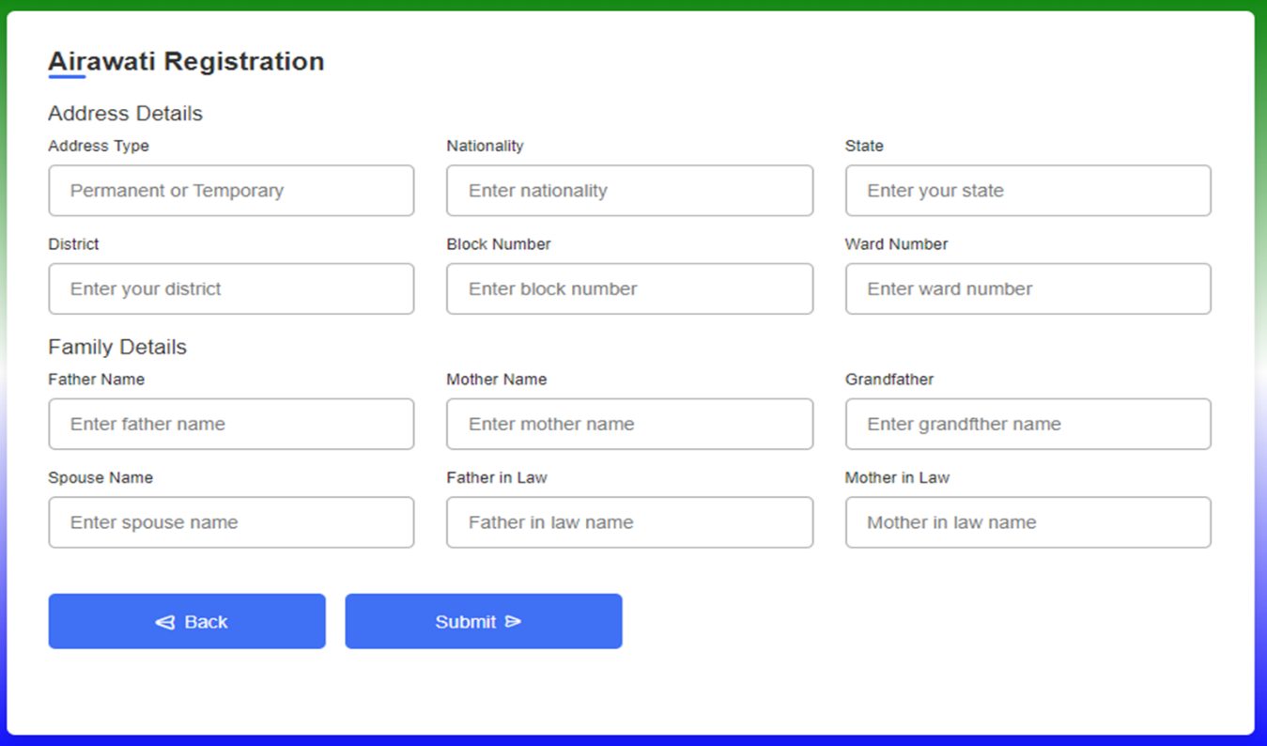

**Registration Add User Details**

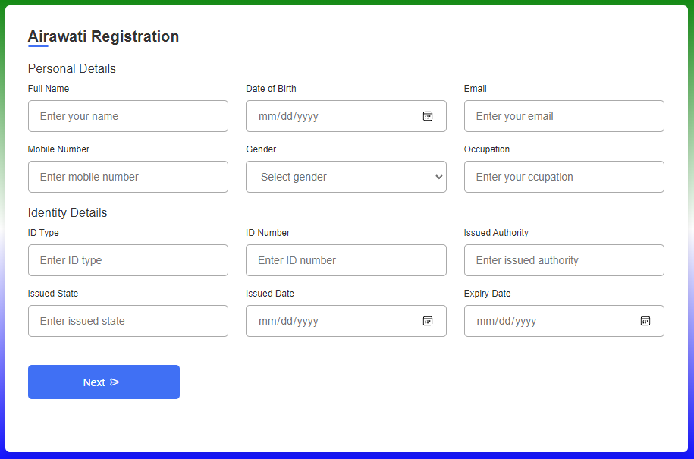

**SYSTEM DESIGN**

**INPUT DESIGN**

Input design in the process of converting user- oriented input to a computer based format. Input design in a part of overall system design, which requires very careful attention. Often the collection of input data is the most expensive part of the system. The main objectives of the input design are

1. Procedure cost effective method of input.
2. Achieve highest possible level of accuracy.
3. Ensure that the input is acceptable to and understood by staff.

**INPUT DATA:**

The goal of designing input data is to make entry easy, logical and free from error as possible. The entering data entry operators need to know the allocated space for each field sequence and which must match with that in the source document. The format in which the data fields are entered should be given in the input form. Here data entry in online ; it makes use of processor that accepts commands and data from the operator through a keyboard. The input required is analyzed processor. It is than accepted or rejected input stages include the following processes.

* Data Recording
* Data Transcription
* Data Conversion
* Data Verification
* Data Control
* Data Transmission
* Data Correction

One of the aims of the system analyst must be to selected be to select data capture method and devices which reduce the number of stage so as to reduce both the changes of error and the cost input type, can be characterized as

External

Internal

Operational

Computerized

Interactive

Input files can exist in document from before being input to the computer. Input design is rather complex since it involves procedures for capturing data as well inputting in to the computer

**OUTPUT**

Outputs from computer systems are required primarily to communicate the results of processing to users. They are also to provide a permanent copy of these result for latter consolation. Computer output is most important and direct source of information to the user. Designing computer output should proceed in an organized well through out the right output must be available for the people who find the system easy use. The outputs have been defined during the logical design stage. If not, they should have defined at the beginning of the output designing terms of types of output connect, format, response etc.

Various types of output there are follows:

* External outputs
* Internal outputs
* Operational outputs
* Interactive outputs
* Turn around outputs

All screens are informative and interactive in such a way that the user can full fill his requirements through asking queries

**DATABASE**

The general theme behind a database is handle information as an integrated whole. A data is a collection of interrelated data stored with minimum redundancy to serve many users quickly and effectively. After designing input and output the analyst must concentrate on database design or how data should be organized around users requirements the general objective is to make information access easy quick, inexpensive and flexible and for other user. During database design the following objectives are concerned:-

* Controlled Redundancy
* Data Independence
* Accurate And Integrating
* More Information At Low Cost
* Recovery From Failure
* Privacy And Security
* Performance
* Ease Of Learning And Use

**SYSTEM IMPLEMENTATION**

Implementation is the stage in the project where the theoretical design is turned into a working system. The implementation phase constructs, install and operates the new system. The most crucial stage in achieving a new successful system is that it will work efficiently and effectively

There are several activities involved while implementing a new project. They are

* End user training
* End user education
* Training on the application software
* System design
* Parallel run and to new system
* Post implementation review

**End user training:-**

The successful implementation of the new system will purely upon the involvement of the officers working in that department. The officers will be imparted the necessary training on the technology.

**End user education:**

The education of the end user start after the implementation and testing is over. When the system is found to be more difficult to understand and complex, more effort is put to educate the end used to make them aware of the system, giving them lectures about the new system and providing them necessary documents and materials about how the system can do this.

**Training of application software**

After providing the necessary basic training on the computer awareness, the user will have to be trained upon the new system such as the screen flows and screen design type of help on the screen, type of errors while entering the data, the corresponding validation check at each entry and the way to correct the data entered. It should then cover information needed by the specific user or group to use the system

**Post implementation view:**

The department is planning a method to know the states of the past implementation process. For that regular meeting will be arranged by the concerned officers about the implementation problem and success.

**SOFTWARE TESTING**

It the menu bar displayed in the appropriate contested some system related features included either in menus or tools? Do pull-down menu operation and tool-bar work properly? Are all menu function and pull-down sub function properly listed; is it possible to invoke each menu function using a logical assumption that if parts of the system are correct, the goal will be successfully achieved. In adequate testing or non-testing will leads to error that may appear few months later.

The create two problems

1. Time delay between the cause and appearance of the problem.
2. The effect of the system errors on files and records within the system.

the purpose of the system testing is to considers all the likely variations to which it will be suggested and push the system to limits.

The testing process focuses on the logical intervals of the software ensuring that all statement have been tested and on functional interval is conducting tests to uncovers errors

**CONCLUSION**

Our project is only a humble venture to satisfy the needs in an institution. Several user-friendly coding has also adopted. This package shall prove to be a powerful package in satisfying all the requirement of the organization.

The objective of software planning is to provide a frame work that enables the mangers to make reasonable estimates made within a limited time frame at the beginning of the software project and should be updated regularly as the project progresses. Last but not least it is no the work that played the ways success but ALMIGHTY

**Bibliography**

Learning Sites:

1. <https://www.w3schools.com/html/>
2. <https://www.codinglab.com>
3. <https://www.w3schools.com/php/default.asp>
4. <https://www.bootstrap.com/html/>
5. https://www.codinglab.com